

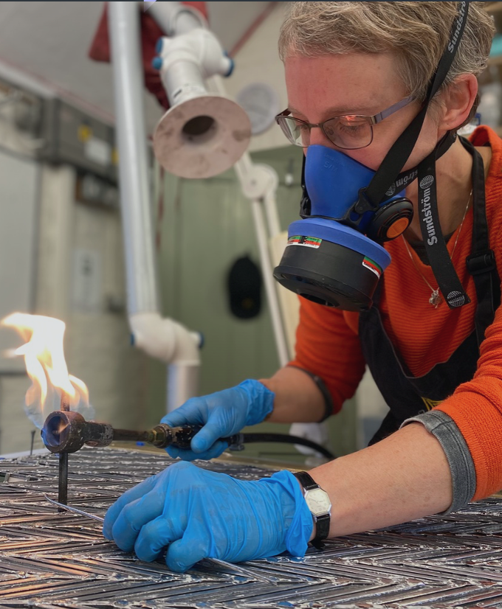

**Apprenticeship/Traineeship**

**Glazing, Metalworking and Site Working**

**Full time:** 37.5 hours a week

**Location:** Central York, with regular off-site working

**Salary:** £22,500 p.a., two-year training contract, with prospect of employment thereafter

**Pension:** 7% Employer’s contribution (The People’s Pension)

**Generous Annual Leave:** in excess of the statutory minimum

**Other Benefits** include: Paid overtime; Annual bonus; Overnight disruption allowance; CPD Allowance; Onsite parking; Perkbox Discount Subscription, plus Employee Assistance Programme; Discounts at York city centre pubs, cafés and businesses:

This is an exciting opportunity for someone with a passion for detail, a commitment to excellence and a strong interest in traditional craft skills and the heritage sector. You will train alongside a team of sector leaders in stained glass craft and conservation, working in and around the magnificent setting of York Minster, with the chance to work at other historic sites throughout the UK, including the University of Oxford and Lincoln’s Inn, London. As a member of a key partner in the York Minster Centre of Excellence in Heritage Skills and Estate Management you will interact with other heritage trades. You will develop high levels of skill in one of the most competitive and sought-after areas of the historic glass and glazing craft. The YGT has a strong track record in training and staff retention, helping its staff into rewarding long-term careers.

**What you will be doing**

* Traditional templating, cut-lining, glass cutting, lead-working, soldering, cementing
* Metal frame fabrication
* Restoration of traditional metal and wood framing and fixing systems
* Work with power tools and specialist fabrication equipment
* Site working, including installation and deinstallation of stained glass and plain glazing
* Learn the principles of protective glazing design, fabrication and installation
* Work closely with our conservators and stained-glass artists
* Work safely in line with current Health and Safety regulation

**Who we are looking for**

* Someone with a passion and pride in working with your hands, and for high quality workmanship
* A natural team player with an appetite for learning from others
* Someone willing to work at height and in all weathers, from scaffolds and ladders: full training will be given
* Someone whose practical skill and desire to do work that contributes to the future of our heritage will matter more to us that your qualifications
* Someone who is over 18 years of age and legally entitled to work in the UK
* Someone with a full clean driving license

If you would like to be considered for this role, please complete the application form and email it with a copy of your CV by **4 March 2024** to [info@yorkglazierstrust.org](mailto:info@yorkglazierstrust.org)

For more information about the York Glaziers Trust, go to: <http://www.yorkglazierstrust.org>

For more information about the York Minster Centre of Excellence, go to:

<https://yorkminster.org/discover/centre-of-excellence-for-heritage-craft-skills-and-estate-management/>

JOB APPLICATION FORM

## Your contact details

Name:

Address:

Phone:

Email:

## Your education and training

Please give details of educational attainment and any training courses attended:

|  |
| --- |
|  |

## 

## Your employment history

### Current or most recent employer:

Name of employer:

Job title:

Gross Basic Salary:

Length of time with employer:

|  |
| --- |
| Duties: |

### Previous employers

Please tell us about other jobs you have done and about the skills you used or learned in those jobs that apply to the role you are applying for with us. If this is your first employment, please provide relevant transferable experiences.

|  |
| --- |
|  |

## 

## Supporting statement

Please tell us about yourself, why you applied for this job, and why you think you are the best person for the job (no more than 500 words).

|  |
| --- |
|  |

## 

## Interview arrangements and availability

If you have a disability, please tell us if there are any reasonable adjustments we can make to help you in your application or with our recruitment process.

|  |
| --- |
|  |

If successful, when can you start working for us?

|  |
| --- |
|  |

## Right to work in the UK

Do you need a work permit to work in the UK? Yes / No

## References

Please give the names and contact details of 2 people who we can ask to give you a reference. We may ask them before an employment offer is made. We will not ask your current employer until we get your permission. If this is your first job since leaving education, you should give your tutors as referees.

### Referee 1

|  |
| --- |
|  |

### Referee 2

|  |
| --- |
|  |

## Declaration

I confirm that to the best of my knowledge the information I have provided on this form is correct and I accept that providing deliberately false information could result in my dismissal.

Name:

Date: